A Comprehensive Analysis of Financial Performance: Insights from a leading Banks

1.INTRODUCTION :

1.1 OVERVIEW:

The banking industry world-wide is being transformed. The global forces for change include technologicalinnovation; the deregulation of financial services at the national level and opening-up to international competition; and - equally important - changes in corporate behavior, such as growing disintermediation and increased emphasis on shareholder value. In addition, recent banking crises in Asia and Latin America have accentuated these pressures. The banking industries in central Europe and Latin America have also been transformed as a result of privatizations of state-owned banks that had dominated their banking systems in the past. In this project we are trying to analysis the bank related data and able to extract some insights from the data using Business Intelligence tools. To Extract the Insights from the data and put the data in the form of visualizations, Dashboards and Story we employed Tableau tool

Purpose :

This session introduces bank financial statements and provides a traditional, ratio-based procedure for analyzing bank financial performance using historical data. It demonstrates the interrelationship between Rank,assests & Assests Propotion . Data are provided that compare the performance characteristics of small banks versus large banks and differentiate between high and low performers arround the world.

2. PROBLEM DEFINITION & DESIGN THINKING:

Business requirements:

The business requirements for analyzing the performance and efficiency of banks

In world include identifying KPIs, comparing performance across different

Countries and states, identifying patterns and trends over time, identifying

Affecting factors, creating interactive dashboards and reports, identifying areas for

Improvement, making data-driven decisions, comparing to the industry average

And creating forecasting models for future performance. The ultimate goal is to Gain insights and improve performance through data visualization techniques

Literature Survey :

A literature survey for the financial analysis of banks would involve researchingAnd reviewing previous studies, articles, and reports on the topic.

This could Include information on the methods and techniques used for financial analysis ofBanks, as well as the results and conclusions of these studies.

Some potential areasOf focus for a literature survey on financial analysis of banks could include:

Ratio analysis, which involves comparing different financial metrics (such asReturns assets, return on equity, etc.) to assess a bank’s performance andCompare it to industry averages or other benchmarks.

Stress testing, which involves simulating adverse economic scenarios to evaluate

A bank’s ability to withstand financial shocks.

Risk management, which involves identifying, assessing, and mitigating the Various risks facing a bank, such as credit risk, market risk, and operational risk.

Basel III, which is a set of international regulatory standards for banks thatIncludes measures for capital adequacy, liquidity, and leverage.

Social or Business Impact.

Social Impact:

Financial analysis of banks can have a significant social impact byIdentifying areas where the bank’s operations or lending practices may be causingHarm to vulnerable communities

For example, a Financial analysis might reveal that a bank is heavily invested in fossil fuel contributing to climate change, or that the bank is disproportionatelyDenying loans to minority-owned businesses, perpetuating economicDiscrimination

Business Model/Impact:

Financial analysis of banks can have a significant impactOn the business operations of the bank itself and its competitors.

For example, aFinancial analysis can help the bank identify areas where it is underperformingCompared to its peers, such as in terms of profitability or asset quality.

ThisInformation can then be used to develop strategies for improving the bank ’s preparation such as by reducing costs, increasing revenue, or improving riskManagement practices.

3.RESULT:

3.1 ACTIVITY AND SCREENSHOT:

1. Top banks according rank and assets
2. Top banks according to total assets
3. Top banks according to country based on total assets
4. Top 10 Countries with assets proportion

5. Country with total assets using funnel chart in increasing order

6. Total assets analysis according to year and quarter

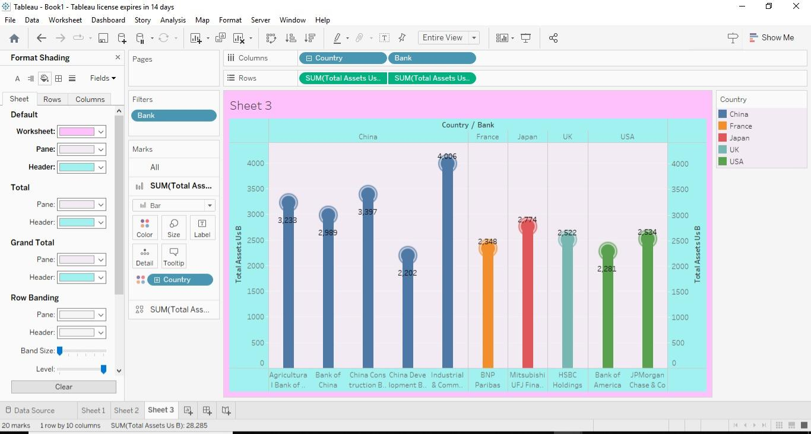

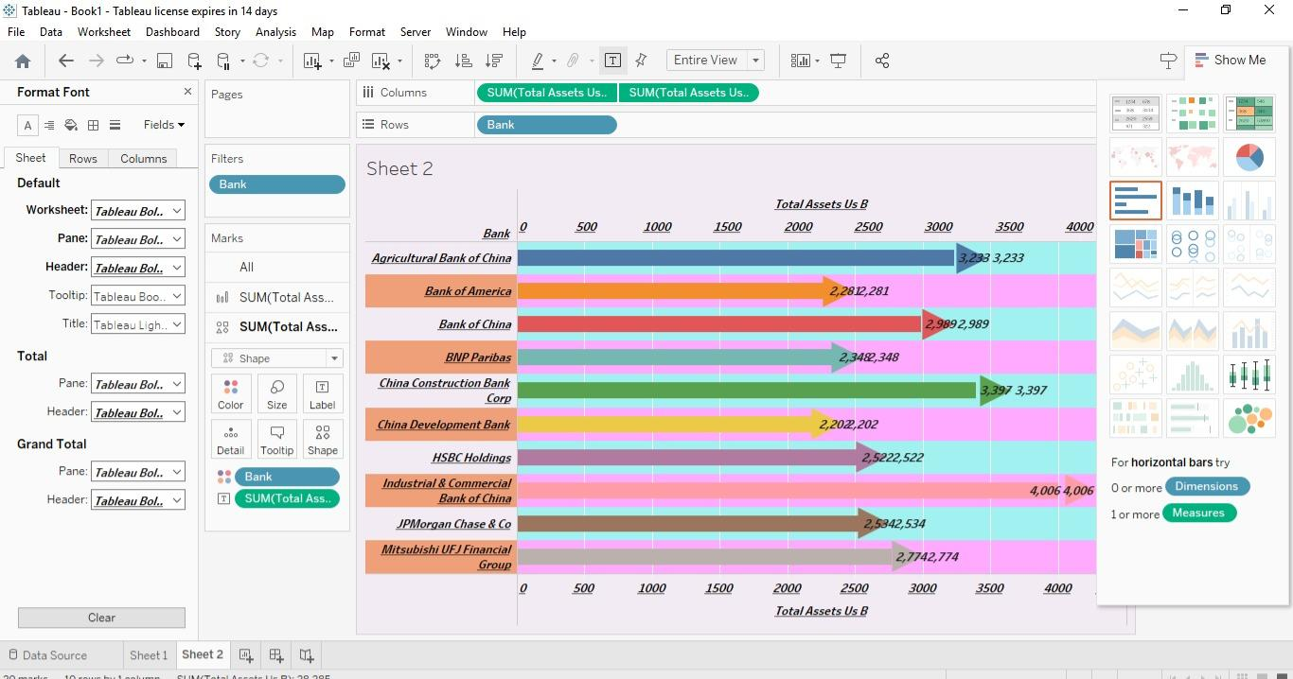

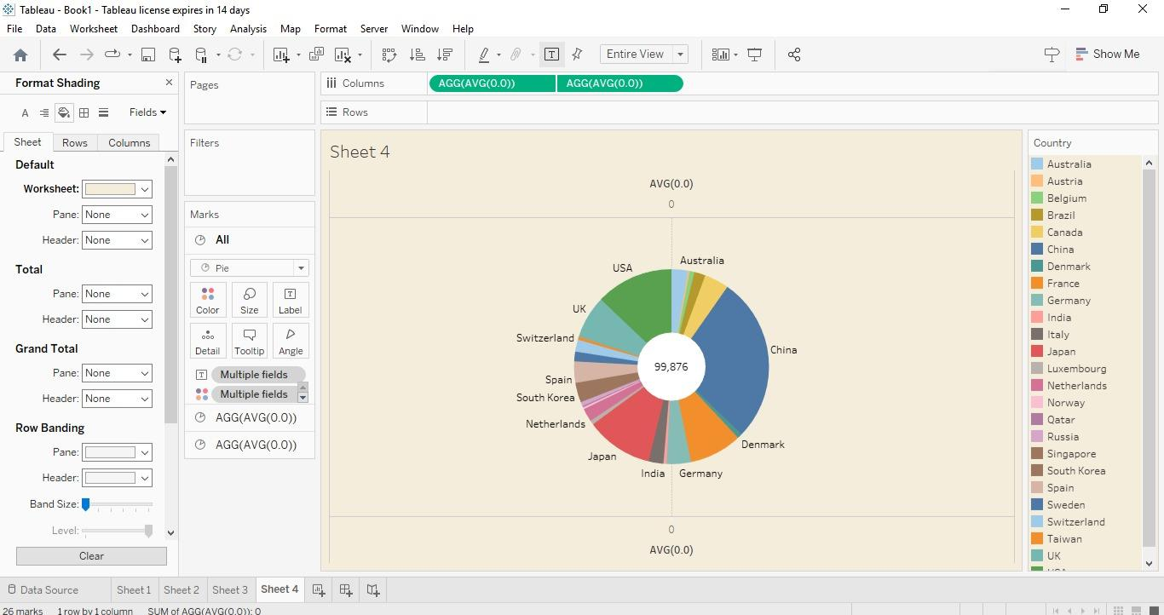

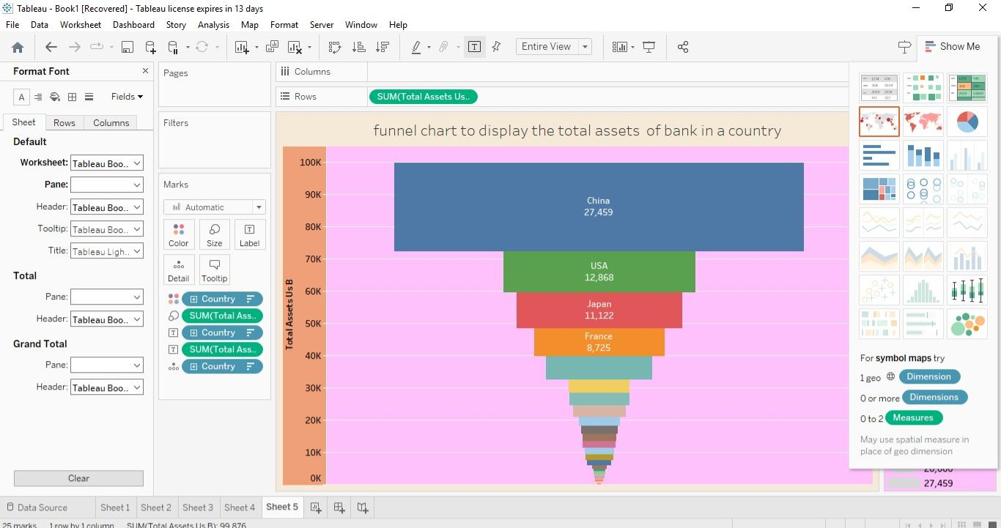

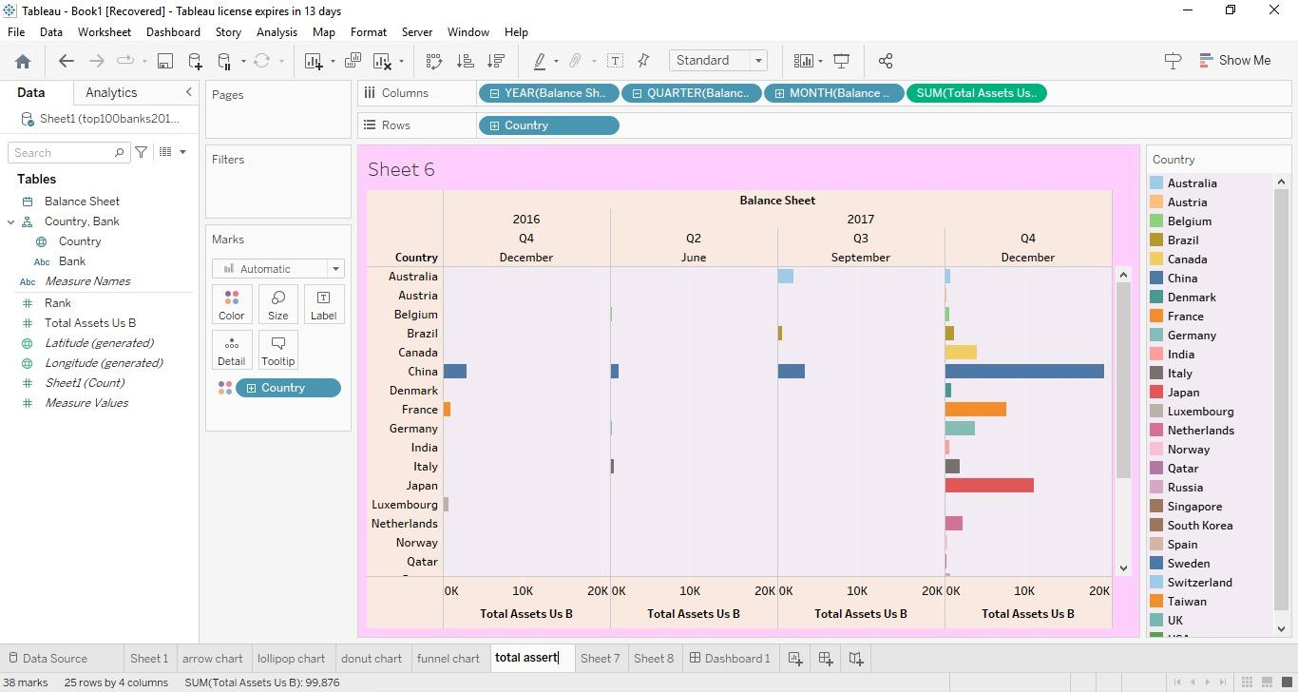4.ADVANTAGES :

The advantages of financial statement analysis are as follows: It helps in deciding whether the company is investible or not. We can analyse the current position of the company in the market by analysing these reports. We can analyse or predict the probability of the future success of the company.

5. DISADVANTAGES:

There are some significant limitations of financial analysis which are the following: The financial analysis does not consider cost-price level changes. The financial analysis is ambiguous if the prior knowledge of the changes in accounting procedure followed by the company is not a

6.APPLICATIONS:

Financial analysis is used to evaluate economic trends, set financial policy, build long-term plans for business activity, and identify projects or companies for investment. This is done through the synthesis of financial numbers and data.

7.FUTURESCOPE:

The field of finance has a huge scope in future. As finance is an integral part of our economy, Financial Managers will always be in high demand. If you want to build a career in finance, the most popular sectors include corporate finance and public banking, credit and financial planning, and asset management

8.CONCLUSION:

Analysis of financial statements is extremely important for every business to grow and increase their revenue. It should not be compromised since it increases the efficiency of business operations. Better processes and expert analysts can help in the detailed analysis process.